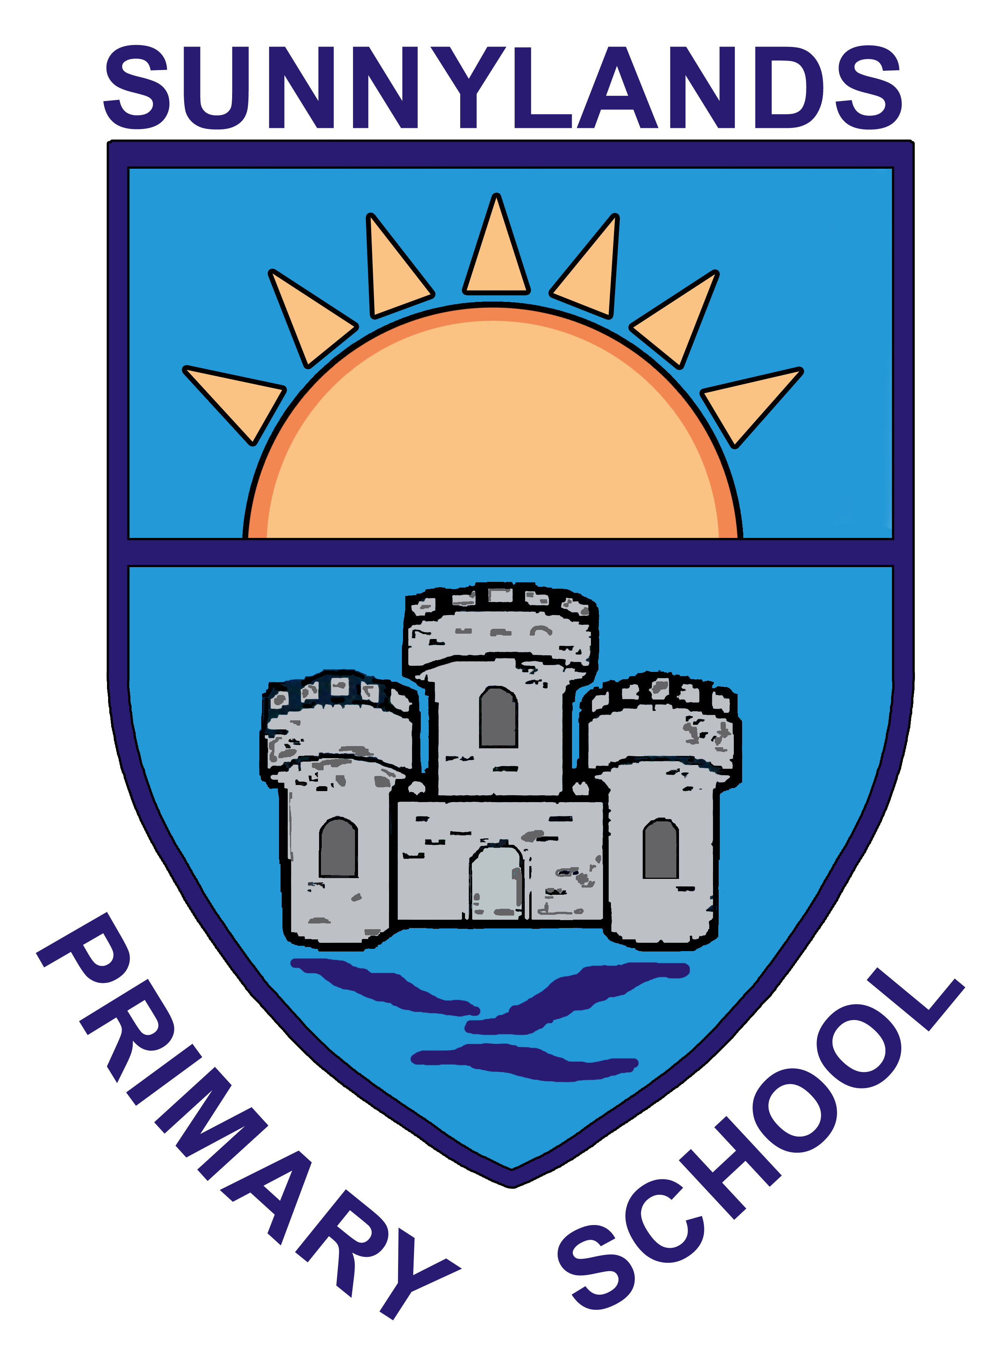

Sunnylands Primary School

8th September 2021

Dear Parent/Guardian,

I have been waiting for further guidance from PHA this morning however in the absence of this and, based on experience of previous cases, I am now moving forward with the advice below to ensure minimal disruption to our children.

I have attached a letter that has been written by PHA and gives advice which you should now follow.

Your child has been a close contact of someone who has tested positive for COVID and therefore you now need to follow the advice, which requires the booking of a PCR test.

A PCR test is a test carried out at a testing centre. This needs to be booked online.

The letter attached gives you a unique code to use when booking the test. 3010860J

Please email the results of the test to jlyons481@c2kni.net when you receive them. Your child must remain at home while awaiting the results of the test.

If your child’s result is negative then they can return to school and retest at day 8. If your child is positive then they must isolate for ten days.

We continue to work together in Sunnylands to ensure we reduce the spread of Covid and to keep our pupils safe.

I appreciate your assistance and understanding at this time.

Ensuring the safety of pupils and staff is my absolute priority and I will continue to monitor this situation carefully and keep you informed.

Parents with any concerns or questions should contact school on 028 93362333 or by email to jlyons481@c2kni.net

Please do not hesitate to contact me if I can be of further assistance.

Kind regards,

Joanne Lyons

