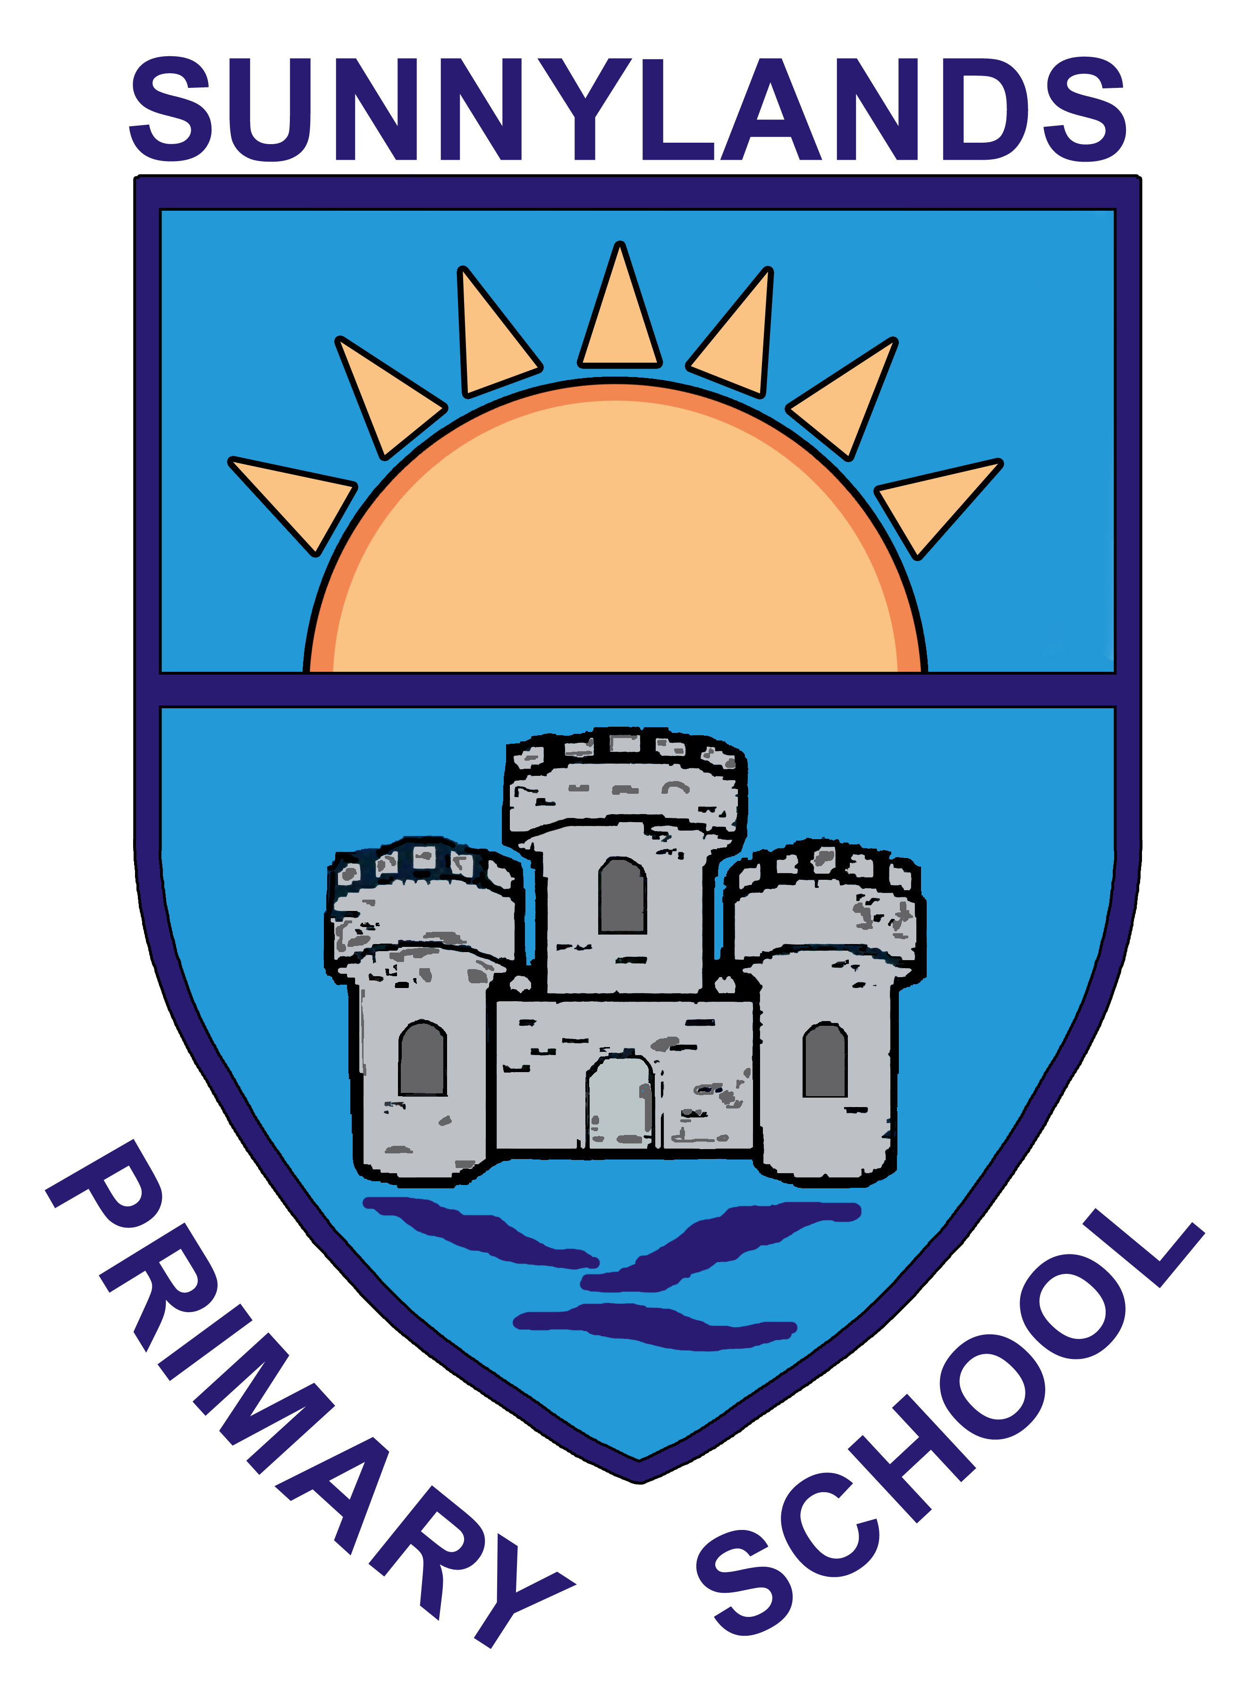

Sunnylands Primary School
Carrickfergus
Northern Ireland
BT38 8JJ
5th October 2020

Dear Parent/Guardian,

Parental Interviews are being held via telephone this year due to COVID restrictions. Class teachers will contact you by phone in the week beginning 19th October. Pupils will finish school on Wednesday 21st, Thursday 22nd and Friday 23rtd October at 1pm to facilitate these interviews.

If your child has an IEP/IBP this will be sent home prior to the telephone call so that you can see it and refer to it throughout the call.

I am aware that not everyone can answer their phone at any point throughout the day eg. If you are working particular hours and therefore the grid below allows you to fill in your availability.

If you are available at any time to take the call you do not need to return this reply slip. The reply can be returned either as a hard copy or via email to myself at jlyons481@c2kni.net

Many thanks,
Mrs J.Lyons

 | 1:30pm-2:00pm | 2:00pm-2:30pm | 2:30pm-3:00pm | 3:00pm-3:30pm | 3:30pm-4:00pm
Wednesday

Thursday

Name of child:

Class:

Parental Signature:

