Signing into Google Classroom

1. You can use the Google Classroom app or search for Google Classroom on the internet.
2. It will ask you to sign in. Every child was given their username for Google Classroom for example [jsmith645@c2ken.net](mailto:jsmith645@c2ken.net). Type your child’s username into the box.

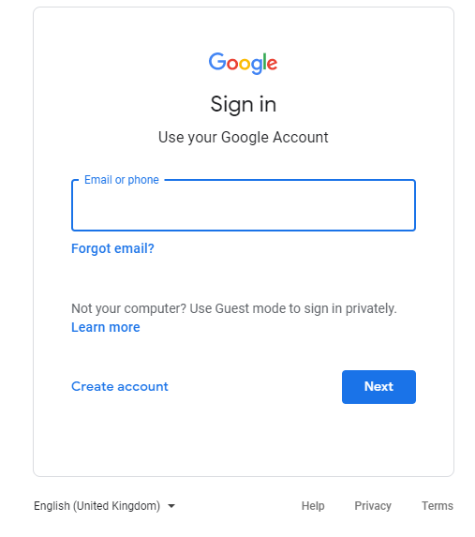

1. 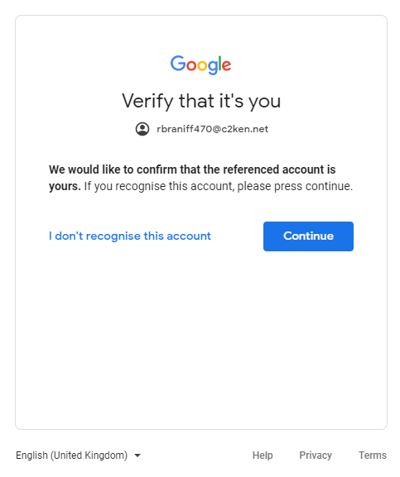It may ask you to verify your account. Click on the ‘Continue’ button.
2. This page may appear when you try to log in. You need to put your child’s username in the top box i.e. [jmsith645@c2ken.net](mailto:jmsith645@c2ken.net). In the box below that, you need to put your child’s password. This was sent home with their username. When you have entered your child’s username and password click on sign in.

Username

Password

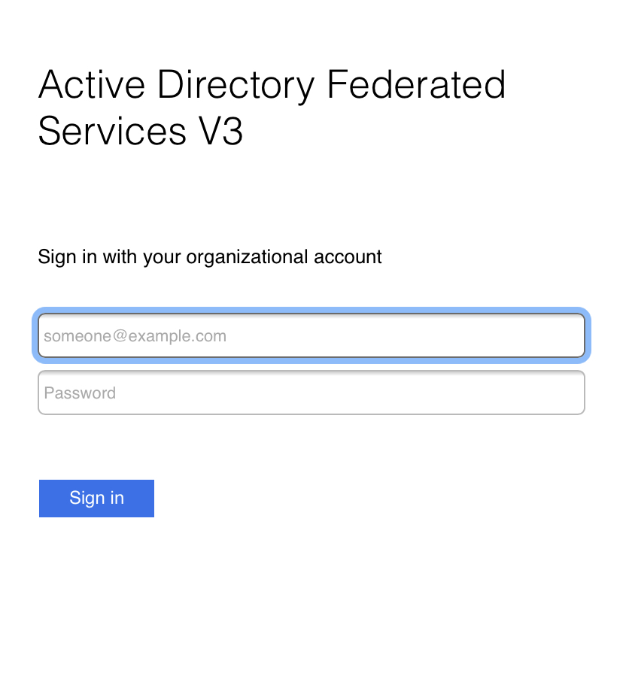

1. 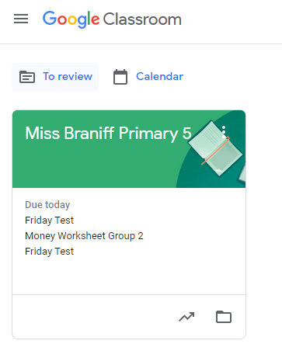You should then be in your child’s Google Classroom.