Changing Expired Passwords
C2k Passwords automatically expire 120 days after they were last reset in order to maintain a level of security on the system.
- If a password expires, or needs to be reset and the user knows their old password they can go to https://services.c2kni.net/ums.
- Enter the required details as per the screenshot below and the new password will be registered
- New password must be at least 8 characters or if using a previous add a number to the start/end
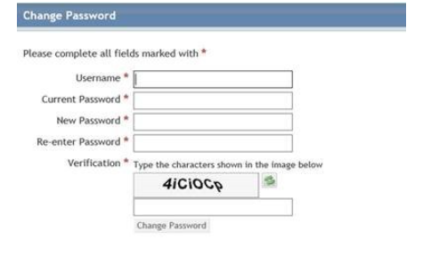

Change your child’s password to the following:

Primary 4 primary4c

Primary 5 primary5c

Primary 6 primary6c

Primary 7 primary7c

