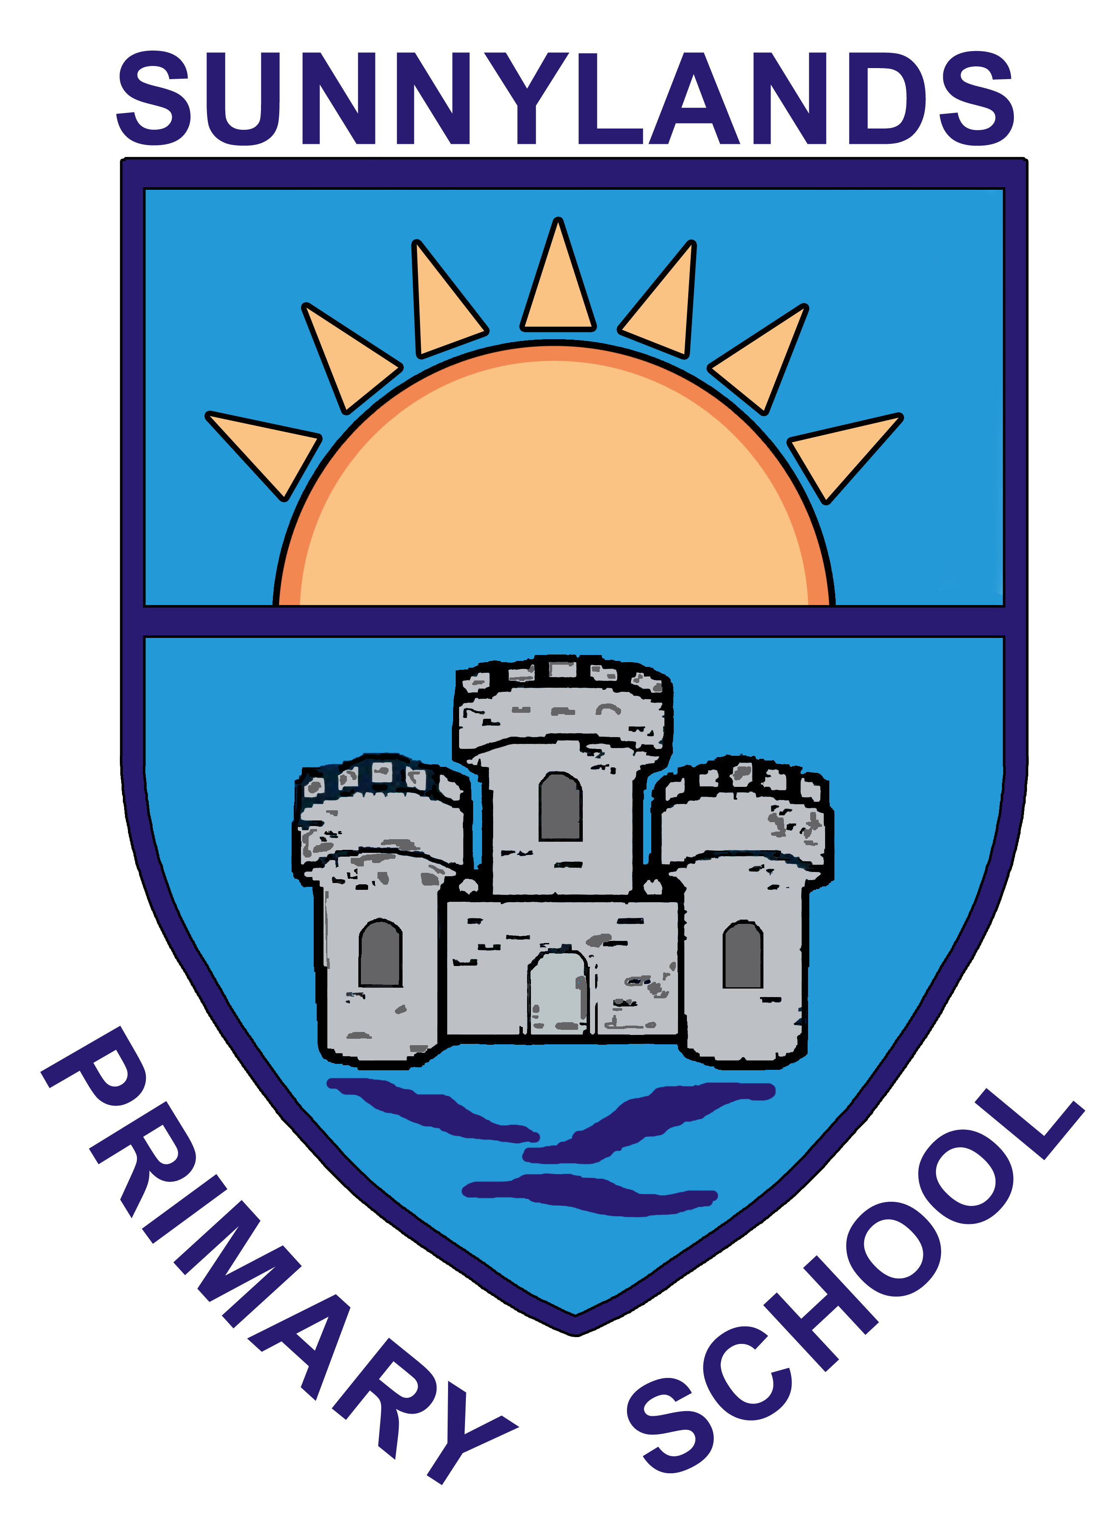

Sunnylands Primary School

14th October 2020

Dear Parent/Guardian,

Our children have been at school for seven/eight weeks now and the progress they have made has been significant. I want to pay a huge tribute to all the staff in Sunnylands, both teaching and non-teaching, for working together to ensure that this has happened. It has taken a lot of hard work and many, many extra hours to ensure your children receive the very best learning we can provide.

Our children have all settled well back into school life and Primary One arrived as if they had always been here, this too has helped in making progress with learning. You, as parents and carers, have given school huge support throughout and have stuck to the guidelines set out by school to ensure we have social distancing and keep each other and our children safe. Thank you!

We have a great team in Sunnylands, children, parents and staff and we have made a huge difference to our children in the past number of weeks since the Restart.

We have now been told that we will be closing from Monday 19th October for a period of two weeks in an effort to stem the infection rate rise in Northern Ireland.

We recognise the difficulty parents face in working with their child/children when at home, keeping their focus, working with more than one child etc. We have decided to supply work in a folder, rather than rely on internet and online learning, in an effort to assist in accessing materials etc. This work will be to cover a one-week period as all children would have been having a break at half term. It is important to allow your child to have leisure time too!

Please try to complete some of the work that has been set so that your child continues with the learning they have been doing. None of this work will be new, it will all be work they have completed in the past number of weeks and so will help them consolidate that learning.

Reading is always of benefit to your child, try to encourage this, there are many sites that provide opportunity to read. Our younger children, particularly those in P1 and P2, need to continue to practice skills such as writing and cutting, using scissors, counting out etc.

Teachers may also use the two online platforms, SeeSaw and Google classroom, to communicate with children and parents and some tasks and ideas may be sent through this during next week. It has however been made clear by the Education Minister in a statement to schools today that teachers should not engage in remote learning and therefore anything sent through this is at the discretion of each individual teacher.
Parent/teacher interviews scheduled for next week will still take place via telephone call, again this is due to the goodwill and commitment of Sunnylands staff.

Half term is the week beginning 25th October and I would urge you to allow your children to have a well-deserved break. Teachers have been working very hard this term, as always, and will be taking time to recharge and ready themselves for the next half term. Teachers will not be posting tasks/work online on the week of 25th October.

No one is looking forward to another week away from our children, we love to see them coming in each morning, we love to see their progress, we love to celebrate their successes.

BUT
Celebrate the opportunity, if you are able, to spend time with your child/children kicking those autumn leaves, throwing them up and having them fall all around, splashing in the puddles, collecting conkers, cooking, crafting. Create memories that you and your children will never forget, it’s the perfect time!

HOWEVER
Please remember that we are here for you if you need us, in whatever way. If you are struggling, in any way, please let us know and we will do everything we can to help. If you are struggling to provide meals for your children we can assist you with this too, please get in touch. We are Sunnylands Family and we really are all in this together.

Please get in contact either by email jlyons481@c2kni.net or message your child’s teacher on SeeSaw or the school mobile number 07783087830 if you need us.

Thank you all for your support throughout this challenging time. Please keep safe.

Mrs J. Lyons

