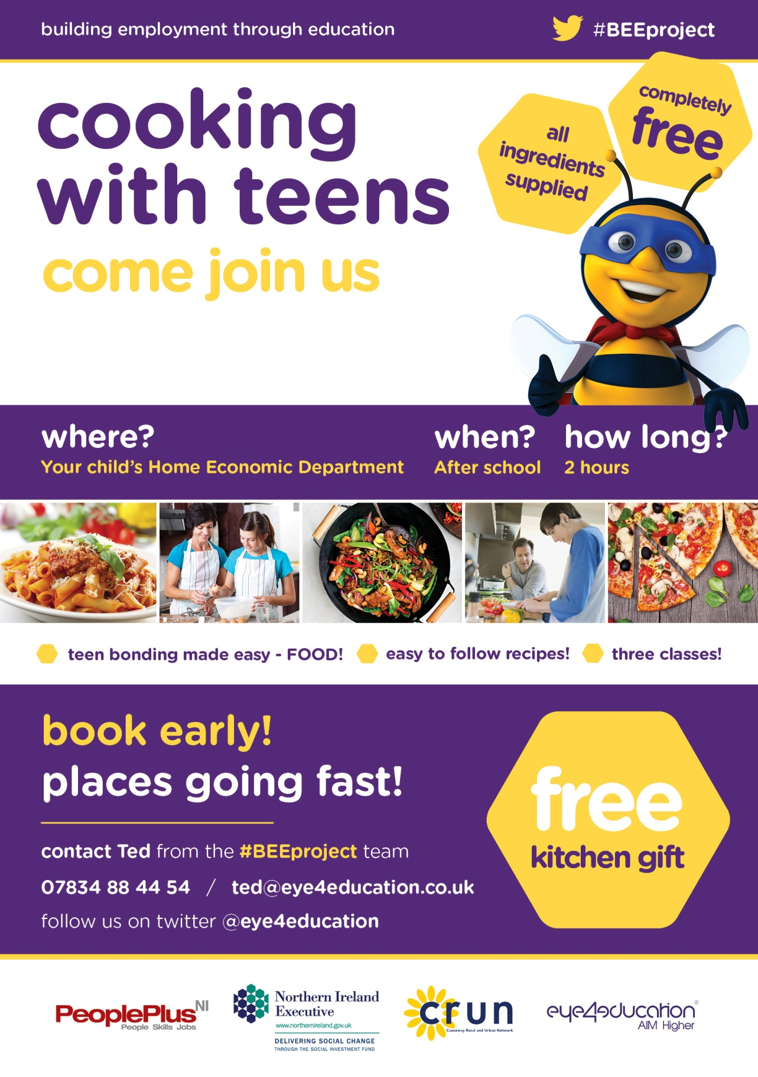0

**book early**

**places going fast!**

**pupils’ name**

**parent/guardian’s name**

**parent/guardian’s phone no.**

**Complete and return to the school office – first come first served!**

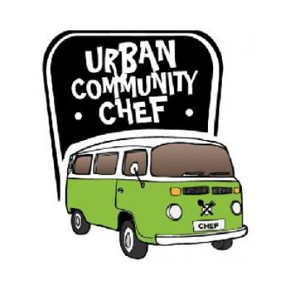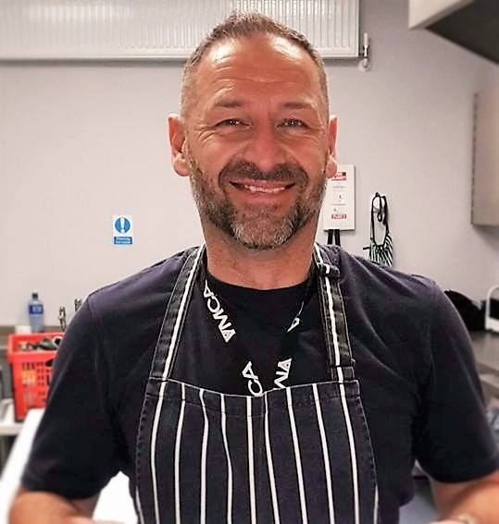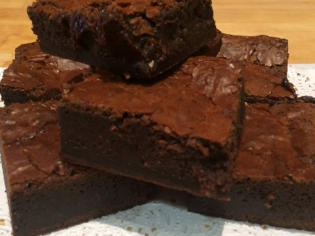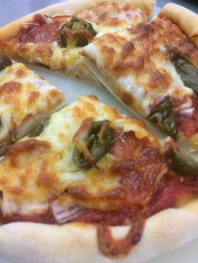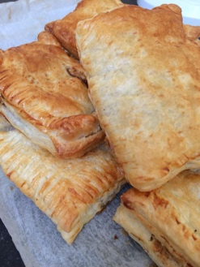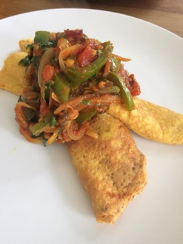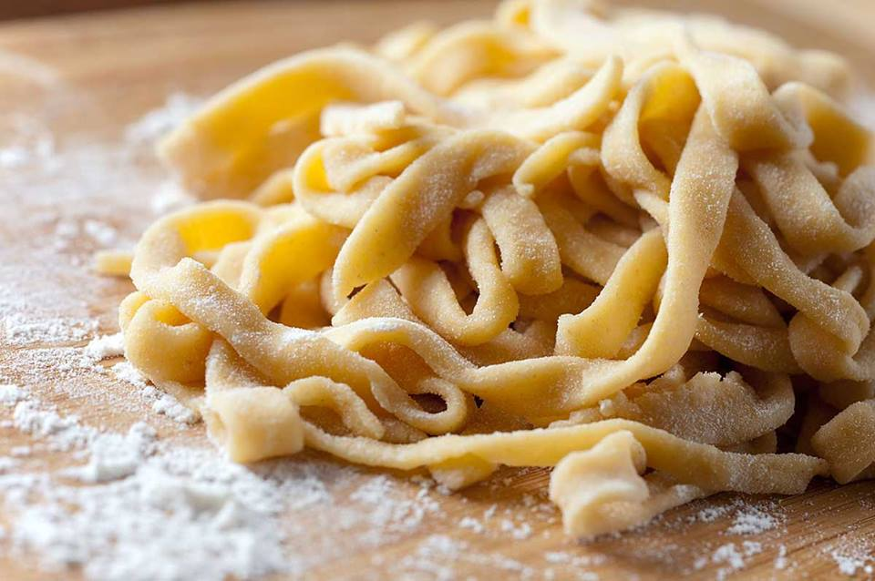

**fun & enjoyable**

**cooking made easy**

**healthy eating recipe’s**

The **URBAN COMMUNITY CHEF**

**is coming to a school near you!!**

**Parents/Grandparents/Guardians**

**come join the URBAN COMMUNITY CHEF**

**and take part in a Cookery Master Class!**

Where? When?

**Sunnylands Primary School Thursday 7th June @ 7.00pm – 9.00pm**

**free**

**toasted sandwich maker**

**FOR ALL!!!**