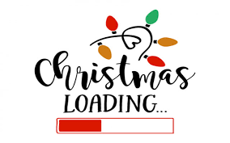

It’s just 93 days ‘til Christmas!!!!
Fear not we can help you to prepare!
Today your child will have brought home a Christmas drawing which can be printed onto a variety of items; Christmas cards, mugs, coasters, cushions etc.
All you need to do is decide which items you would like and return the form and the money in an envelope to school. We will do the rest!
Christmas sorted!!

In order to have the items in plenty of time for Santa we need the form and the orders returned by Thursday 7th October.

